Letter to the Bishop
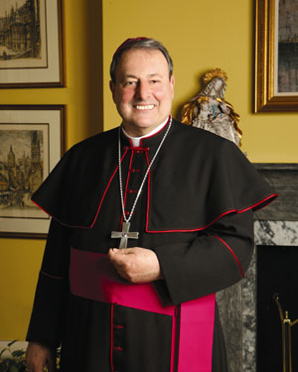

A one-paged, personal, handwritten letter on appropriate stationary or good quality paper is required.

In the letter include
- A little information about yourself.
- Why you want to be confirmed.
- Your Patron Saint’s name and briefly give information about your Saint’s life
- Why you chose your Patron Saint.
- How is your Patron Saint going to inspire you to live a good, Catholic life.

