**What’s the BIG DEAL**

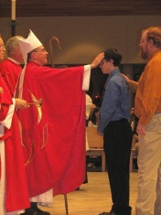

**ABOUT CONFIRMATION?**

“Confirmation is when you get a new name.” (YOUCAT: 203-207)

“Confirmation is what I have to do because…”

“Confirmation has to do with being a grown up in the Church.”

What is Confirmation?

* Confirmation is a sacrament in which we receive the Holy Spirit,
* we are joined more closely to the Church
* and we are made strong to bear witness to Jesus Christ

So…What does this **REALLY** mean?

* A Sacrament is a visible sign of God’s grace instituted by Christ and given to the Church. These outward signs help us feel the Sacrament as well as receive it spiritually. We use our five senses during Mass and many of our services. It is part of our Catholic Traditions that have been given to us by the Apostles and Early Fathers of the Church about 2000 years ago. We use incense during special Masses. We see the smoke rising as a visual image of our prayer being lifted to Heaven. The aroma is also a reminder of Heaven. We can feel the water of Baptism when we enter the Nave of the church before Mass and when Father sprinkles us with Holy Water at special Masses. We hear the bells during the Eucharistic Prayer to alert us that the miracle of Transubstantiation is occurring. We taste of the Bread and Wine which is Jesus’ Body and Blood, which is nourishment for our soul.
* You will receive the Holy Spirit. The Holy Spirit is the third person of the Holy Spirit. He is equal with the Father and the Son.

Pentecost is the Birthday

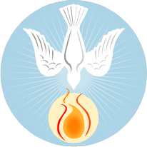

Of the Church

* All of the Apostles, Mary, and many of Jesus’’ followers were in the Upper Room (the room of the Last Supper) and received the courage to witness of Jesus’ Good News and begin the Church. (Acts 2:1-19)
* You are joining more closely to the Church. You became a member of the Church at your Baptism, but Confirmation joins us more closely to the Church.
* The Holy Spirit gives you the strength to defend and live the faith of the Catholic Church and bear as a witness of Jesus Christ.
* You will receive the Seven Gifts of the Holy Spirit at your Confirmation Mass. You will always have these gifts imprinted on your heart and soul. These gifts are only good if you use them as God intended you to use them. Like receiving a gift for Christmas or Birthday. You unwrap it, use it as was intended and share it! Your Gifts of the Holy Spirit are given to you to use for the glory of God and His Church.

**Gifts of the Holy Spirit**

1. **Wisdom**
2. **Understanding**
3. **Right Judgment/Counsel**
4. **Courage/Fortitude**

**This is Bishop Guglielmone’s favorite!**

1. **Knowledge**
2. **Reverence/Piety**
3. **Wonder and Awe/Fear of the Lord**

**(Hint: This is on the final test.)**

* Confirmation as a sacrament evolved from the early Church. Between 800AD to 1200AD, Roman tradition spread in Europe. The purpose of Confirmation was to strengthen the faith of the Baptized. During this era children were confirmed before the age of 2 years. The bishop slapped instead of anointed the child to symbolize the spiritual battle facing believers. (Christian suffered horrific persecutions during different period in history.) This practice stopped a long time ago. By 1972, the sacrament became more like a sacrament of Christianity maturity. We now freely and maturely commit ourselves to the Catholic Church at Confirmation. Confirmation concludes the Sacraments of Initiation.

**The Seven Sacraments**

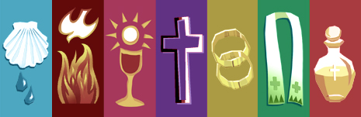

* The Sacraments of Initiation-

Baptism

Communion

Confirmation

* The Sacraments of Healing -

Reconciliation

Anointing of the Sick

* The Sacraments of Vocation

Holy Orders

Matrimony

Baptism inoculates us from original sin, but we still have **concupiscence.** This means we are in a state of a weakened will. God gave us FREE WILL to choose right from wrong. We mess up so we need all of the Sacraments to keep us on the path to heaven. **Confirmation is like a booster inoculation to keep you strong in the faith.**

When you are Baptized as an infant, your parents and Godparents promise to teach you or make sure you learn and live the Catholic Faith. They were in charge of bringing you up in the faith. **With Confirmation you will learn more about your faith as a mature person and receive the Gifts of the Holy Spirit to help you defend and live your faith.**

At this time in your life you may feel a lot of your “friends” tugging you in the wrong direction. You may feel mixed up about what your parents, God, and the Church are telling you. If you **use** the Gifts of the Holy Spirit that you receive at Confirmation, you will be lead in the right direction.

Nobody said it would be easy to get to Heaven, but you have more support than you think. Your God, your Catholic Community, your Sacraments, your family and your friends are all here to help you open all of the Gifts of the Holy Spirit and use them wisely.

C:\Documents and Settings\Theresa Jameson\Local Settings\Temporary Internet Files\Content.IE5\K2VW5ZBD\MC900433492[1].wmf