Our Lady of the Lake Catholic Church
Confirmation Final Exam 2014-2015
Name____________________________________

List the Seven Gifts of the Holy Spirit: (HINT: WURK CAR)
- WISDOM
- UNDERSTANDING
- REVERENCE
- KNOWLEDGE
- COURAGE
- WONDER AND AWE
- RIGHT JUDGEMENT

List the Twelve Fruits of the Holy Spirit: (HINT: C J P P K G G G F M S C )
- CHARITY OR LOVE
- JOY
- PEACE
- PATIENCE
- KINDNESS
- GOODNESS
- GENEROSITY
- GENTLENESS
- FAITHFULNESS
- MODESTY
- SELF-CONTROL
- CHASTITY

What are the four mysteries we meditate on while we pray the Rosary? (HINT: JSLG)
- JOYFULL
- SORROWFULL
- LUMINOUS
- GLORIOUS

.The two main parts of the Mass: Liturgy of the….
- WORD
- EUCHARIST

Match the Holy Days of Obligation with the date. (ANSWERS: D E F B A C)

___________January 1st
___________40 days after Easter
___________August 15th
___________November 1st
___________December 8th
___________December 25th

- Immaculate Conception
- All Saints Day
- Nativity of our Lord
- Mary, Mother of God
- Ascension
- Assumption

Match the color with the Liturgical Season: (ANSWERS: D A B C)

____________Ordinary Time
____________Pentecost, Honoring the Holy Spirit, and Confirmation
____________Lent and Advent
___________Christmas, Easter and Celebrations of Mary

- Red
- Violet, Purple or Deep Blue
- White
- Green

Fill in the blank with the words below

Sacrament
Actual grace
Gospels
Chrism
Transubstantiation
Seal of Confession
Four Marks of the Church
Sin
Universal
Holy Trinity
Nicene Creed
Apostles Creed
Pentecost
- TRANSUBSTANTIATION is the scholastic term used to designate the unique change of the Eucharistic bread and wine into the Body, Blood, Soul and Divinity of Christ.

- NICENE CREED is the Creed we profess at Mass.

- THE FOUR MARKS OF THE CHURCH are the One, Holy, Catholic, and Apostolic Church

- THE HOLY TRINITY is God the Father, God the Son, and God the Holy Spirit.

- CHRISTIAN is any Baptized person.

- INRI is the inscription on the top of the crucifix which means “Jeusu of Nazareth: King of the Jews”.

- The word Catholic means UNIVERSAL.

- THE APOSTLES CREED is the Creed we profess at the beginning of the Rosary.

- A SIN is an offense against God.

- CHRISM is the oil used in Confirmation.

- ACTUAL GRACE IS the free and undeserved gift that God gives us so we can become His adopted Child.

- THE SACRAMENTS ARE instituted by Christ and given to the Church. They are visible signs of God’s sanctifying grace.

- The SEAL OF CONFESSION is a vow taken by priests that means that anything confessed during the Sacrament of Confession is never revealed by a priest to anyone even under the threat of torture of death.

- Matthew, Mark, Luke, and John wrote the GOSPELS.

- PENTECOST is the birthday of the Church.
.
The Sacraments of Initiation are
- BAPTISM
- HOLY EUCHARIST
- CONFIRMATION
The Sacraments of Healing or Mercy are:
- CONFESSION
- ANOINTING OF THE SICK
The Sacraments of Vocations are:
- HOLY ORDERS
- MATRIMONY

Who is the Holy Trinity?
- FATHER
- SON
- HOLY SPIRIT
Circle the correct answer. Apologetics means (D)
- Defending the Catholic Church
- Giving an informed answer to someone who asks about your faith.
- Apologizing for being a Catholic
- Both A. and B.

We have three ways to study the Bible
- Sacred TRADITION-oral teachings handed down from Jesus to the Apostles and then to their disciples and eventually handed to us.
- Sacred SCRIPTURE-a collection of books canonized as inspired by God.
- The MAGISTERIUM-the teaching authority of the Church.

.
The Bible is divided into 2 main sections:
- THE OLD TESTAMENT
- THE NEW TESTAMENT
Name the Four Marks of the Church from the Nicene Creed
- ONE
- HOLY
- CATHOLIC
- APOSTOLIC
Which Creed do we pray at Mass? Circle one

The Apostles Creed

The Nicene Creed

Which Creed do we pray as we begin the Rosary? Circle one

The Apostles Creed

The Nicene Creed
____________________________________

The Theological Virtues are RECEIVED FROM the Holy Spirit. The more we use them, the closer we become to God.

- FAITH is like trust. This helps us believe in God and give our lives to Him.
- HOPE is looking to the future with a positive attitude. This virtue helps us through bad time and helps us look forward to the happiness of Heaven with God.
- CHARITY OR LOVE ties all of the virtues together. 1 Corinthians 13:13, “So faith, hope and CHARITY OR LOVE remain, but the greatest of these is CHARITY OR LOVE.

The Cardinal Virtues are moral issues. We use these to choose the way to God.
- PRUDENCE helps us choose the right the to do. This helps us stop, think and then act with good sense.
- JUSTICE is being respectful to the rights of others. It means being fair and considering the needs of others.
- FORTITUDE is courage to do the right thing even though it is hard.
- TEMPERANCE is a balance between what we want and what we need. We use this to build self- control.
The Seven Precepts of the Church are the basic requirements of the Catholic Church.
- To attend MASS, and HOLY DAYS OF OBLIGATION, and resting from servile works.
- To observe the days of ABSTINANCE and FASTING which are Ash Wednesday and Good Friday and not to eat meat on Fridays during Lent.
- To CONFESS our sins to a priest at least once a year.
- To receive OUR LORD JESUS CHRIST IN THE HOLY EUCHARIST at least on a year during Easter
- To CONTRIBUTE to support the Church in time, talent and treasures.
- To obey the laws of the Church concerning MATRIMONY.
- To participate in the Church’s mission of the EVANGELIZATION Of SOULS. (Missionary Spirit of the Church)

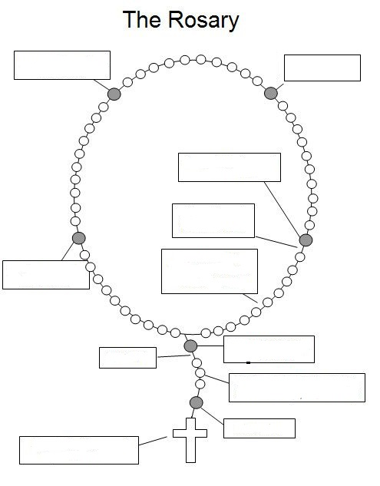

The Head of the Catholic Church is POPE FRANCIS.

The Bishop of the Diocese of Charleston is THE MOST REVERNEND ROBERT GUGLIELMONE.

The Cathedral of the Diocese of Charleston is ST. JOHN THE BAPTIST CATHEDRAL.

Our Lady of the Lake Clergy:
Our Pastor is FATHER ANDREW VOLLKOMMER.

Our Deacons are:
- DEACON GREG WEIGOLD
- DEACON MALCOLM SKIPPER

The Newspaper of the Diocese is
THE CATHOLIC MISCELLANY

Extra Credit: 5 points each
Write the Hail Mary and the Our Father

